QUESTION : 1
Create a SQL query using a subquery in the WHERE clause to find all restaurants from a 'Restaurants' table whose average rating is higher than the average rating of all restaurants in the city :

TABLE Restaurants :
CREATE TABLE Restaurants(
restaurant_id INT,
restaurant_name VARCHAR(100),
city VARCHAR(50),
rating DECIMAL(2,1),
PRIMARY KEY(restaurant_id)
);

VALUES :
INSERT INTO Restaurants (restaurant_id,restaurant_name,city,rating)
VALUES
(1,'Dominos','Ahmedabad',4.5),
(2,'Pizza Hut','Ahmedabad',4.2),
(3,'La Pinoz','Ahmedabad',4.8),
(4,'Burger King','Ahmedabad',3.9),
(5,'McDonalds','Ahmedabad',4.6);

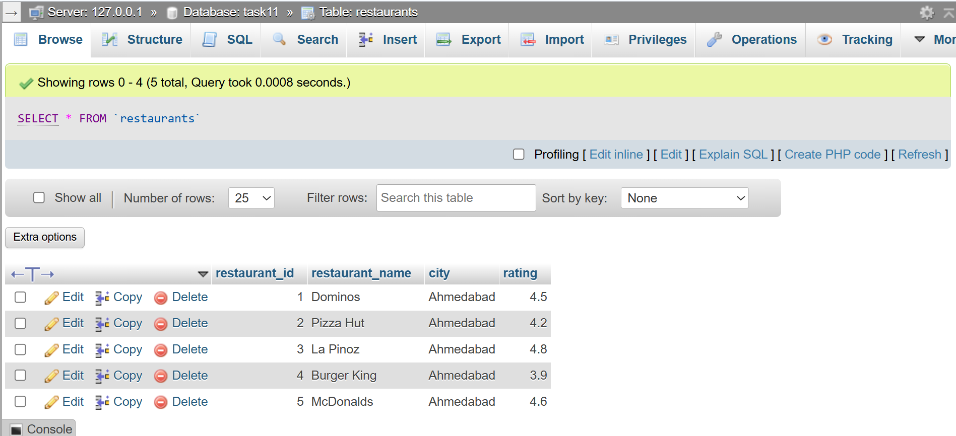
SELECT * FROM Restaurants WHERE rating >
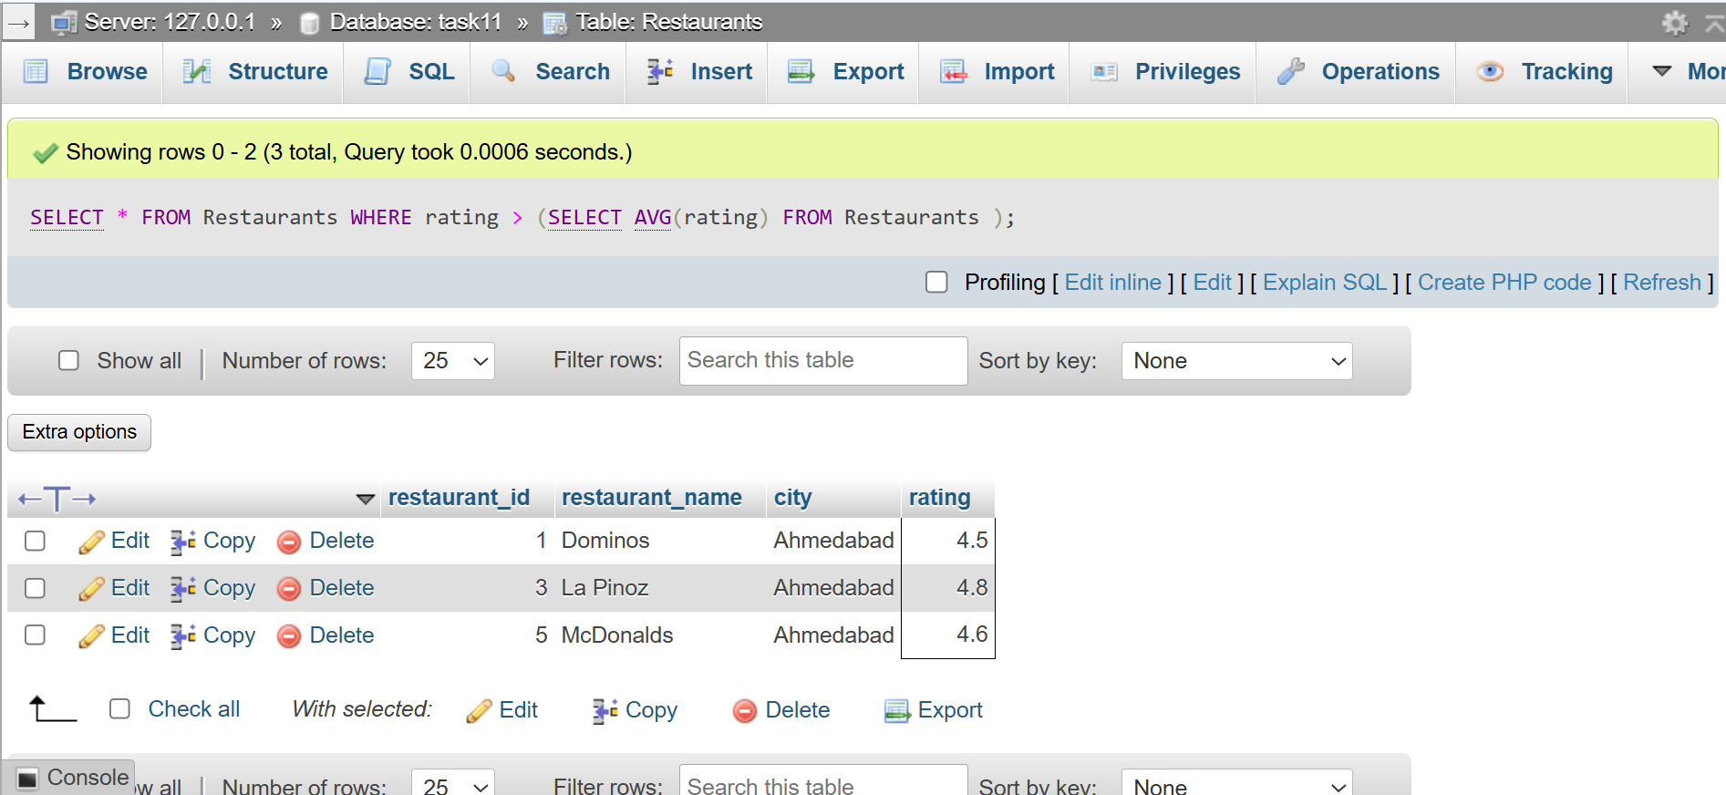
(SELECT AVG(rating) FROM Restaurants );
QUESTION : 2
Write a SQL query that uses a subquery in the SELECT statement to display each user's name from a 'Users' table along with the total number of orders they have placed from an 'Orders' table, like a summary you might see in a Zomato user profile :
TABLE Users:
CREATE TABLE Users(
user_id INT,
user_name VARCHAR(100),
PRIMARY KEY(user_id)
);
INSERT INTO Users (user_id,user_name) VALUES
(1,'Vivek'),
(2,'Rahul'),
(3,'Priya'),
(4,'Neha');
TABLE Orders:
CREATE TABLE Orders(
order_id INT,
user_id INT,
order_amount DECIMAL(10,2),
PRIMARY KEY(order_id)
);
INSERT INTO Orders (order_id,user_id,order_amount) VALUES
(101,1,350), (102,1,500),
(103,2,700), (104,3,250),
(105,3,400), (106,3,150);

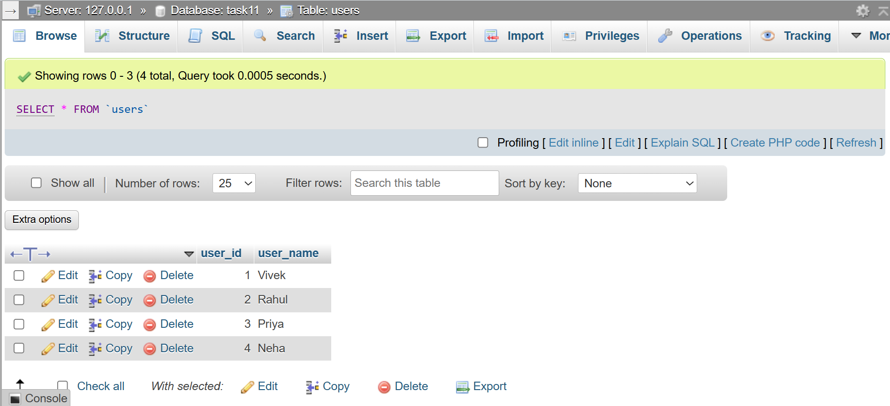
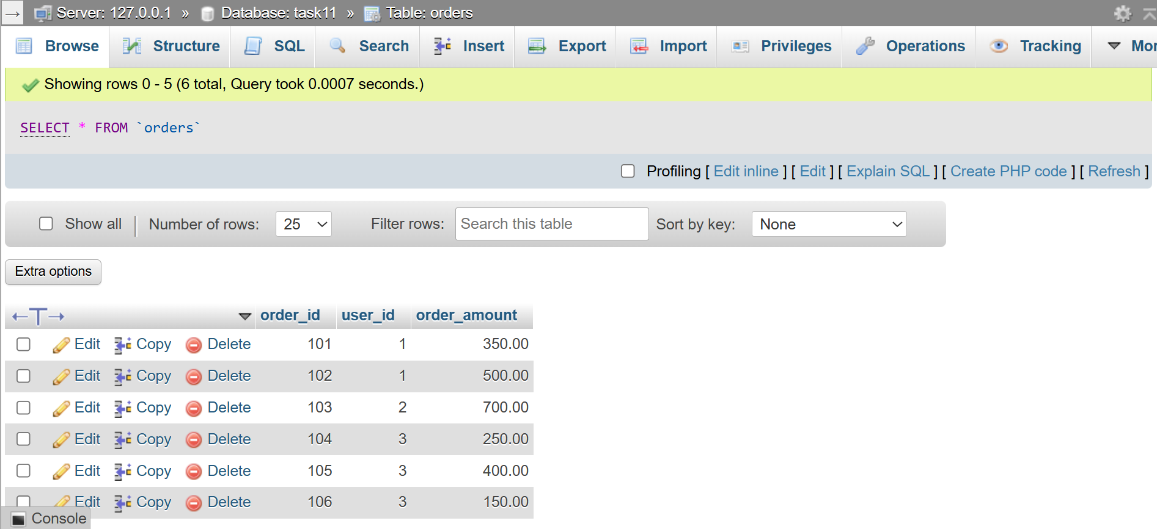
SELECT user_name,
(SELECT COUNT(*) FROM Orders WHERE Orders.user_id=Users.user_id)
AS Total_Orders FROM Users;
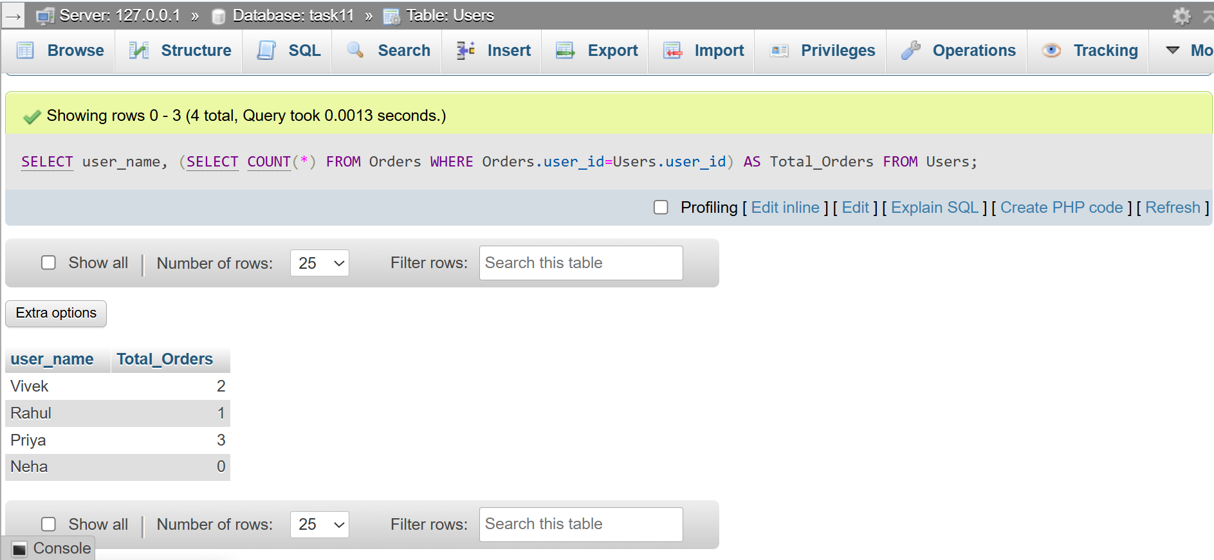
QUESTION : 3
Given a 'Movies' table and a 'Reviews' table, write a SQL query using IN with a subquery to list all movies that have at least one review with a rating of 5 stars, as seen in BookMyShow's top-rated section :
TABLE Movies :
CREATE TABLE Movies(
movie_id INT,
movie_name VARCHAR(100),
PRIMARY KEY(movie_id)
);
INSERT INTO Movies(movie_id,movie_name)
VALUES
(1,'KGF'), (2,'Pushpa'),
(3,'Leo'), (4,'Jawan');

TABLE Reviews :
CREATE TABLE Reviews(
review_id INT,
movie_id INT,
rating INT,
PRIMARY KEY(review_id)
);
INSERT INTO Reviews(review_id,movie_id,rating)
VALUES (101,1,5),(102,1,4),(103,2,3),
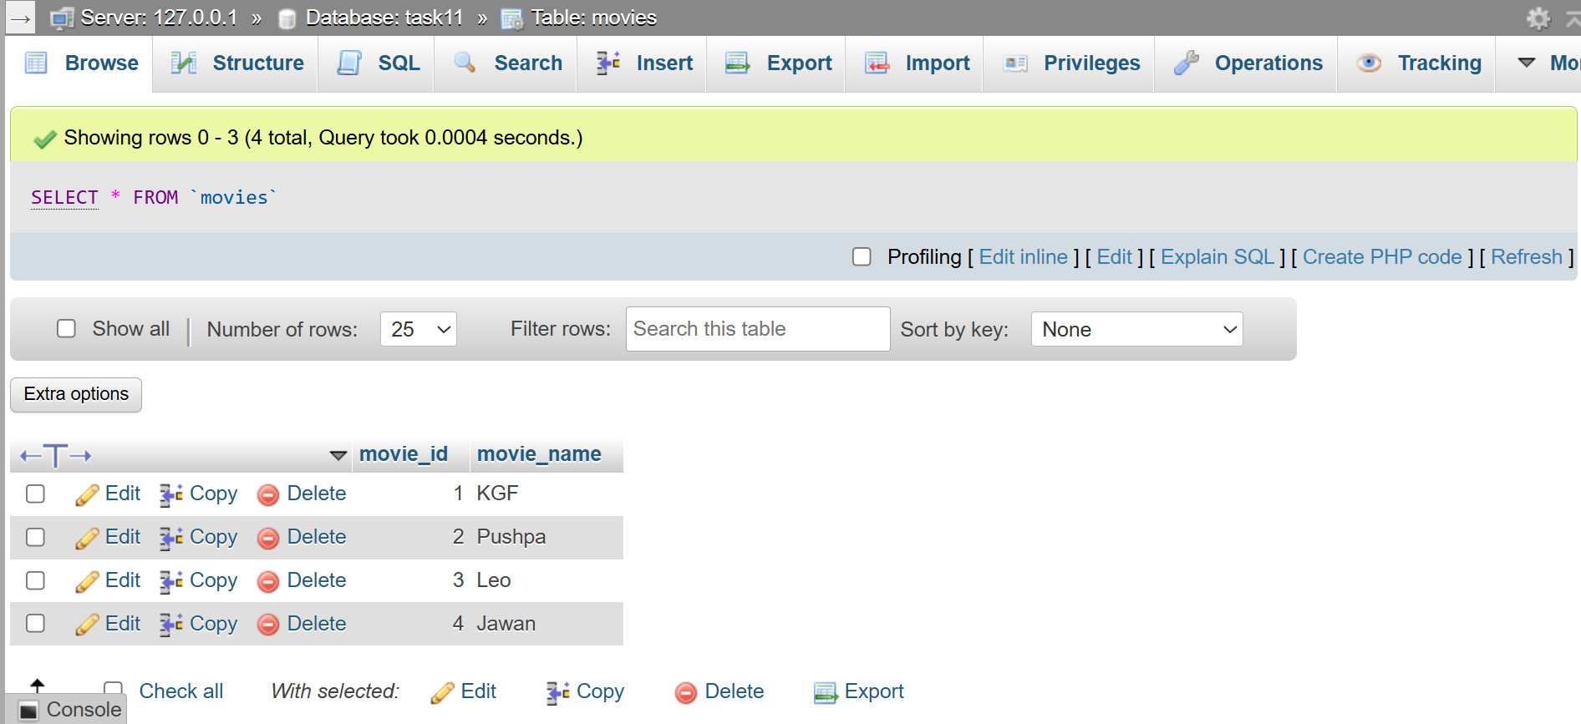
(104,3,5),(105,4,2);
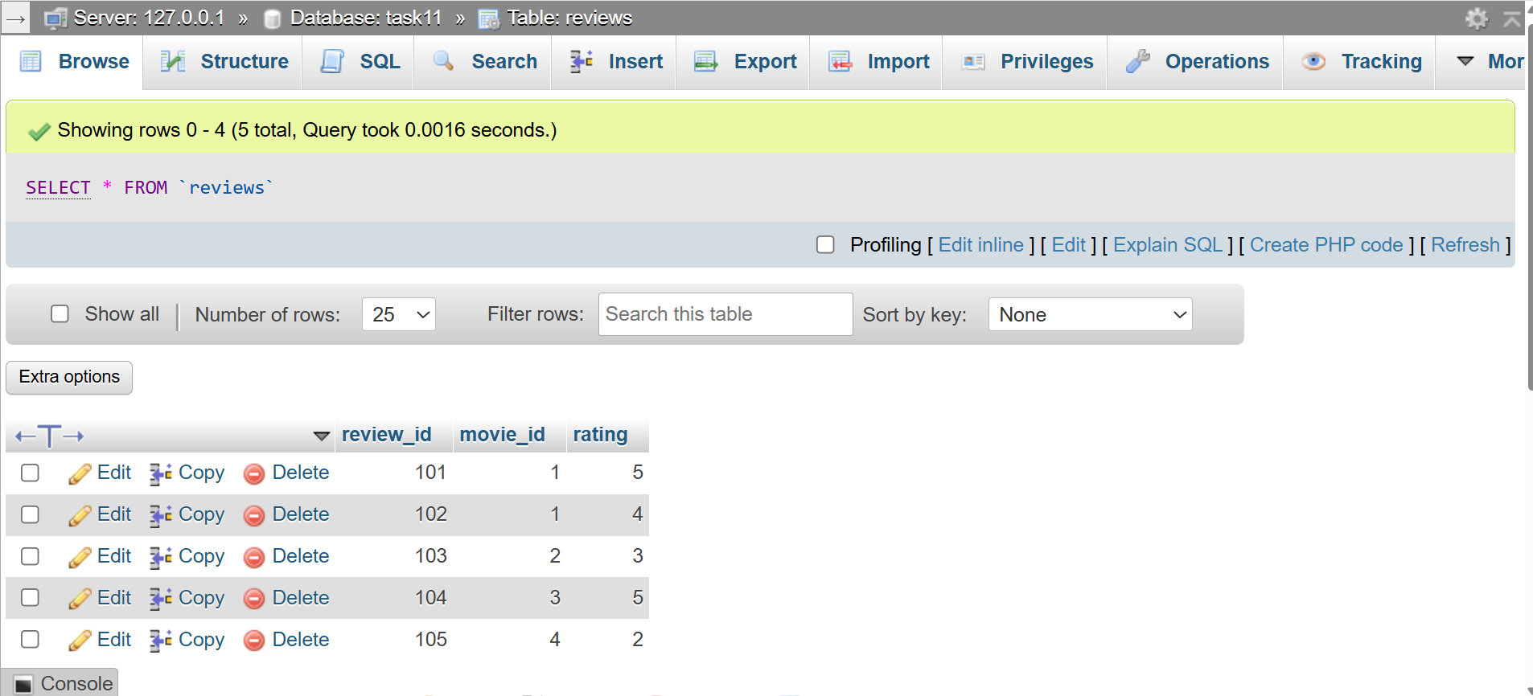
SELECT * FROM Movies WHERE movie_id IN
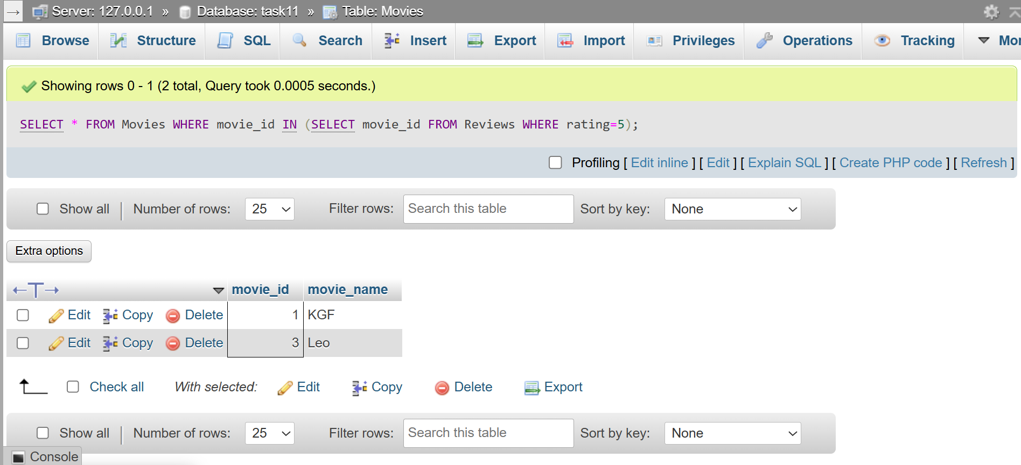
(SELECT movie_id FROM Reviews WHERE rating=5);
QUESTION : 4
Write a nested SQL query to find the names of all sellers from a 'Sellers' table on a Flipkart-style platform who have sold products in every category listed in a 'Categories' table.<br><br><em><strong>Hint:</strong> Use nested subqueries to compare seller's categories with the complete list of categories.</em> :
TABLE Sellers :
CREATE TABLE Sellers(
seller_id INT,
seller_name VARCHAR(100),
PRIMARY KEY(seller_id)
);
INSERT INTO Sellers(seller_id,seller_name)
VALUES
(1,'ABC Store'),
(2,'XYZ Mart'),
(3,'Super Seller');

TABLE Categories :
CREATE TABLE Categories(
category_id INT,
category_name VARCHAR(100),
PRIMARY KEY(category_id)
);

INSERT INTO Categories(category_id,category_name)
VALUES(1,'Electronics'),(2,'Fashion'),(3,'Home');

TABLE Products :
CREATE TABLE Products(
product_id INT,
seller_id INT,
category_id INT,
product_name VARCHAR(100),
PRIMARY KEY(product_id)
);

INSERT INTO Products(product_id,seller_id,category_id,product_name)
VALUES (101,1,1,'Laptop'), (102,1,2,'Shoes'), (103,1,3,'Chair'),
(104,2,1,'Mobile'), (105,2,2,'T-Shirt'), (106,3,1,'TV'),
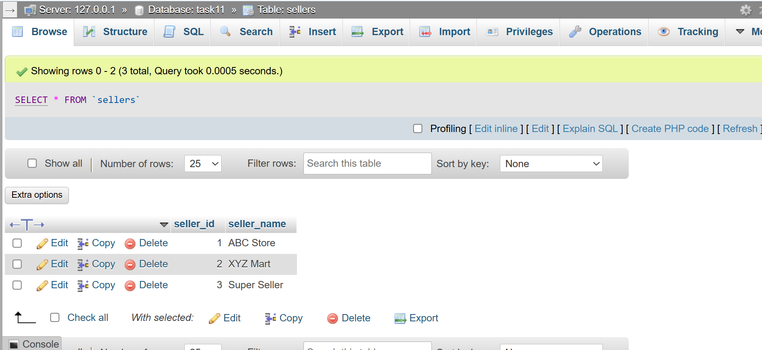
(107,3,2,'Jeans'), (108,3,3,'Table');
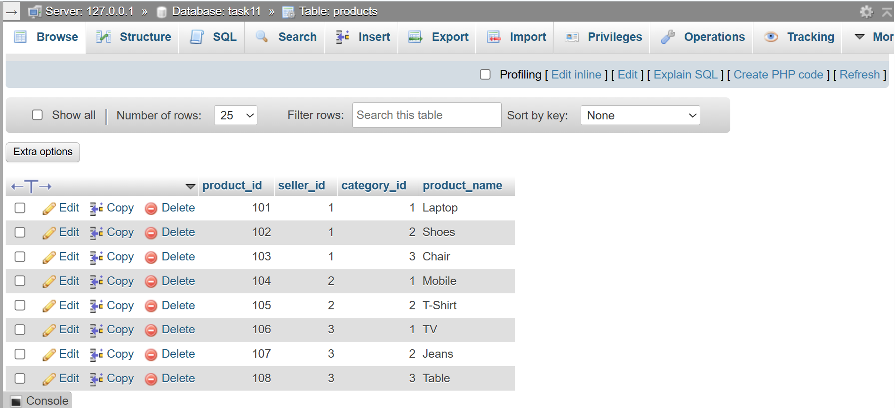
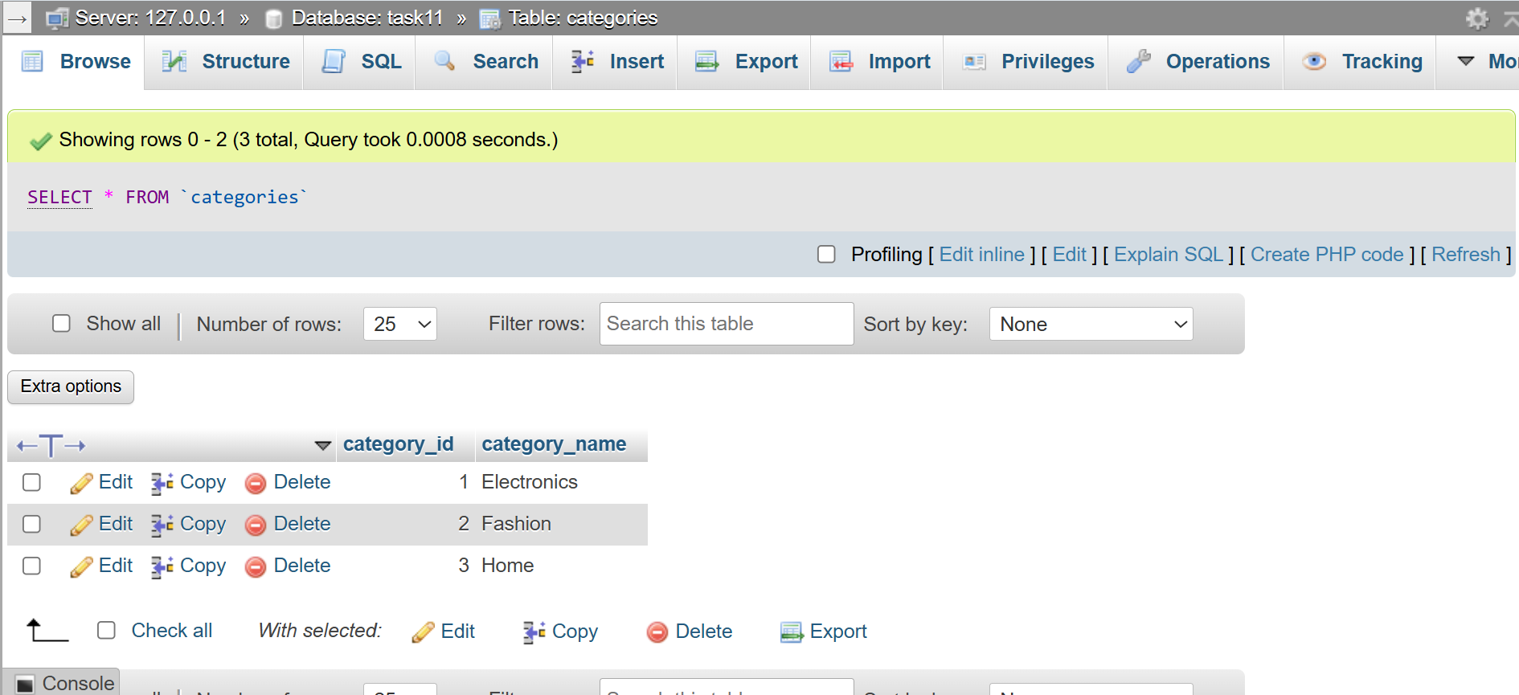
SELECT seller_name FROM Sellers As s WHERE NOT EXISTS
(SELECT * FROM Categories As c WHERE NOT EXISTS
(SELECT * FROM Products As p WHERE p.seller_id=s.seller_id
AND p.category_id=c.category_id
)
);
